AIM- To design a LED flasher.

APPARATUS:

Arduino Board, LED, Bread board, wires etc.

Circuit Diagram

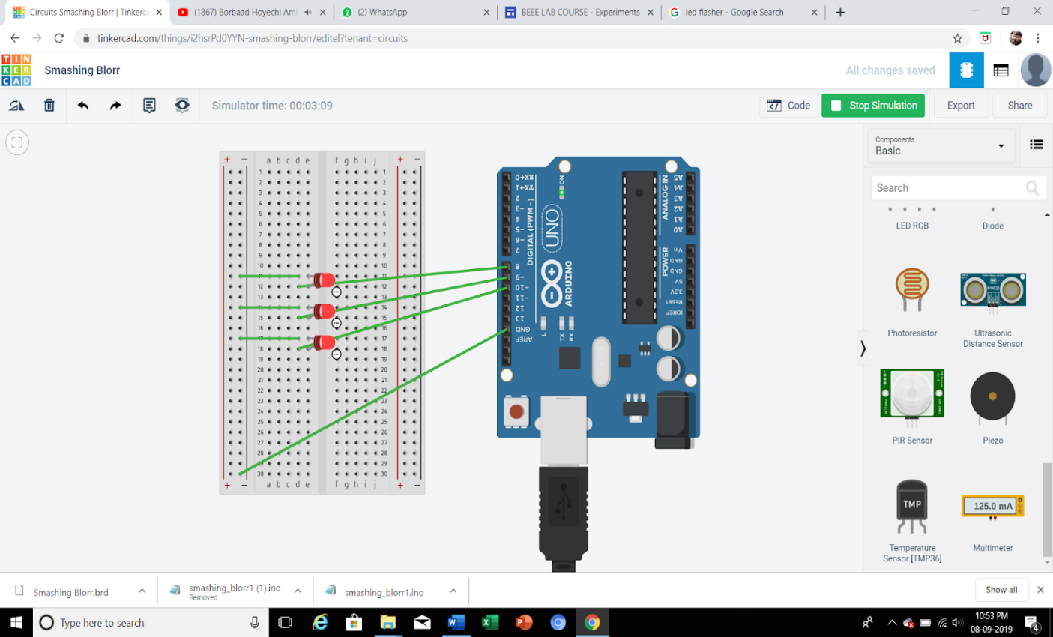

THEORY:

LED flashers are semiconductor integrated circuits that are used switch on and off the lights in a pattern, or as indicated in the situation. They are used as a decorative light in diwali occasion for irregular brinking in a pattern. They are also found in circuits used as indicators and controllers, as well as in

home-built projects.

CONCEPT USED:

1. p-n junction concept is used in this experiment

2. Designing the circuit on breadboard

3. Using loops and creating logic codes for arduino board.

LEARNING AND OBSERVATION:

LEARNING:

1. Arduino board’s bsic concepts are learnt by me.

2. Likewise, arduino board has Digital pins and Analog pins. Generally , negative teriminal is connected to ground or low votage to have a potential difference.

3. Digital pin provides Input as well as Output, but Analog

pin provides only input.

4. The Arduino board has ~ sign in Digital pin side which is

also known as Pulse Width Modulation.

5. These pins help’s in getting analog results with digital

means.

6. How a circuit on breadboard is placed so that it can

work properly.

7. Digital Pin provides 5V Power supply to the circuit.

OBSERVATIONS:

1. If we connect the ‘n’ terminal of the LED to other

terminal except ground(GND), hence the circuit will be

incomplete and we cannot get the desired output.

2. I connected the ‘p’ terminal of the p-n junction diodes to

the Digital pins 9 in combination with the resistance, and ‘n’

3. If we connect the ‘p’ junction of LED to the 5V of

analog the the light will not blink it will remain to glow.

PROBLEM AND TROUBLESHOOTING:

1. I have connected the ‘p’ terminal of the LEDs to analog

side 5V terminal, but we cannot use that terminal

because it can take input only it cannot provide output

like digital terminals.

2.The LEDs were not glowing due to its loose connection.

By reinserting it again I was able to fix this issue.

3. I have written the code for 7 number digital pin instead

of 9

4.Then I rechecked the code and corrected the error.

PRECAUTIONS:

1. The connections should be tight and firm.

2. We have the check the voltage before operating the

board as high voltage might destroy the micro

components of the board.

3. We have to look correctly which wire are we putting

where, neglecting which might create error.

4. Port should be clearly checked to remove the troubleshoot problem.